TRIBHUVAN UNIVERSITY

INSTITUTE OF ENGINEERING

PULCHOWK CAMPUS



A REPORT

ON

NOODLES FACTORY OPERATION AND PROCESS OPTIMIZATION

**SUBMITTED BY:**  **SUBMITTED TO:**

PURUSHOTTAM THAKUR (077BEL030) Er. SANJEEVAN SATYAL

BIPIN PRASAD DEVKOTA (077BEL019) DEPARTMENT OF APEKSHYA SHAKYA (077BEL009) COMPUTER ENGINEERING

BODHIT KUNWAR (077BEL021)

# AKNOWLEDGEMENT

We would like to extend my heartfelt gratitude to all those who have supported and contributed to the completion of this report. Without their assistance, dedication, and encouragement, this project would not have been possible. First and foremost, we are deeply thankful to deputy head of department of Electronics Engineering, **SANJEEVAN SATYAL** for his valuable guidance, insightful feedback, and unwavering support throughout the entire research process. His expertise and encouragement were instrumental in shaping this report. We are also grateful to the staff and faculty of **CG FOODS**, whose resources, facilities, and expertise provided a conducive environment for conducting the necessary research and experiments. Additionally, we would like to express our appreciation to the participants who generously volunteered their time and cooperation, making our data collection process smooth and successful. Special thanks go to my colleagues and friends who offered their support, insightful discussions, and encouragement whenever we needed it. In conclusion, this report would not have been possible without the collective efforts and support of all those mentioned above, and for that, we are sincerely grateful.

Sincerely,

Purushottam Thakur

Bipin Devkota

Apekshya Shakya

Bodhit Kunwar

# ABSTRACT

This report presents a detailed analysis of the operations and process optimization strategies employed in **CG FOODS COMPANY.** The main objective of this study is to identify opportunities for enhancing productivity, efficiency, and product quality within the factory. It consists of the interview of the personnel of the company and data collection on various aspects of the production process. This report provides raw material procurement, storage, and handling procedures, as well as the manufacturing processes, packaging, and distribution. Our team has found out that this company maintain the systematic and scientific way for the food safety and quality standards throughout its operations. However, by the study our team come to know that there are certain areas where improvements could be made. Specifically, we identified opportunities to optimize the production line layout, reduce processing time, and minimize waste generation. Additionally, our research highlights the potential benefits of adopting automation and smart manufacturing technologies in selected stages of the production process. Integrating these technologies could lead to further efficiency gains, cost savings, and reduced human error. In conclusion, this report provides valuable insights into the current state of operations at **CG** **FOODS COMPNAY** and proposes actionable recommendations for process optimization and sustainability improvements. Implementing these measures can enhance productivity, reduce operational costs, and position the factory as a model of best practices in the noodles manufacturing industry.

**TABLE OF CONTENTS**

ACKNOWLEDGEMENT……………............................................................... ii

ABSTRACT……………….................................................................................iii

TABLE OF CONTENTS.....................................................................................iv

1. INTRODUCTION............................................................................................1

1.1. Profile table..................................................................................................2

1.2. Objective......................................................................................................3

2. LITERATURE REVIEW…………………………………………………….4

3. BACKGROUND THEORIES…………………………………………..........5

4. METHODOLOGY………………………………….......................................6

4.1 Manufacturing Process.................................................................................7

4.2 Existing System.............................................................................................8

4.3 Recommendation of the system………………………………………….....9

4.4 Algorithm………………………………………………………………….10

4.5 Flowchart…………………………………………………………………..11

4.6 Circuit Diagram……………………………………………………………12

5. EPILOGUE…………………………………………………………………...20

5.1 RESULT…………………………………………………………………..20

5.2 DISCUSSION…………………………………………………………….20

5.3 CONCLUSION…………………………………………………………...22

5.4 FUTURE ENHANCEMENT……………………………………………..22

6. LIST OF FIGURES…………………………………………………………..23

7. REFERENCES……………………………………………………………….28

**1. INTRODUCTION**

CG Foods, the parent company of Wai Wai, founded in 1984, is a part of the Chaudhary Group, a Nepalese conglomerate, and is based in Kathmandu, Nepal. It has become one of the leading brands in the instant noodle industry, known for its delicious flavors and global popularity. Over the years, the brand has expanded its reach to various countries, making Wai Wai noodles a household name in many parts of the world. The materials used to produce this noodle. The primary ingredients used in the production of instant noodles Wai Wai are given below-

Wheat Flour: Wheat flour is the main ingredient used to create the noodle dough. It provides the base for the noodle's texture and structure.

Palm Oil: Palm oil is often used as the cooking oil to pre-fry the noodles, which helps in reducing cooking time for consumers.

Starch: Modified starch is added to improve the texture and consistency of the noodles.

Salt: Salt is used to enhance the flavor of the noodles.

Seasoning Mix: The seasoning mix consists of various spices, herbs, and flavorings that give the noodles their distinct taste. This mix may include ingredients like garlic powder, onion powder, chili powder, soy sauce, and other spices.

Dehydrated Vegetables: Some instant noodle variants come with dehydrated vegetables like carrots, peas, corn, or green onions to add extra flavor and visual appeal.

Antioxidants: Antioxidants are used to enhance shelf life and prevent the noodles from becoming rancid.

Water: Water is added to the dough to create the noodle texture during the manufacturing process.

Their products are manufactured with features-

* Quick and easy to prepare
* Wide range of flavors and variants
* Portable and shelf-stable
* Customizable with preferred ingredients
* Enriched with essential vitamins and minerals
* Global appeal and popularity
* Easy preparation process
* Suitable for vegetarians and vegans
* Trusted brand with consistent quality

|  |  |
| --- | --- |
| **Name** | CG Foods Pvt. Ltd |
| **Parent company** | Chaudhary Group (CG) |
| **Headquarter** | Kathmandu, Nepal |
| **Year of Establishments** | 1984 |
| **Key customers** | Common individual |
| **Key Product** | Waiwai instant noodles |
| **Industry** | Food and Beverage |
| **Global presence** | India, Bangladesh, Thailand, USA, Nigeria, and more |
| **Founder** | Mr. Binod K. Chaudhary |
| **Team and staff** | 92 |
| **Installation and testing facilities** | Yes |

**Profile Table**

**1.2 Objective**

The main objective of doing case study is to visit the chosen organization and learn its operation under supervision of senior engineers and technicians and to get familiar with the use of instrumentation in real fields. Also, we were guided to understand the current control system of this organization and think for merit and demerit of the present system being used.

Hence the main objective of our visit can be summarized as the following-

* To study the existing management system and technology of company and to find the ways to make it more better.
* To be familiar with various engineering aspects and role of engineers in the particular company.
* To gain insights into the various instrumentation systems used in the manufacturing process of Wai Wai noodles which includes observing and studying the sensors, controllers, and other devices used for process automation and monitoring.
* To examine how instrumentation is used to optimize energy consumption and reduce environmental impact in the manufacturing process.
* To observe the present system closely and purpose solutions to boost the performance and efficiency of the system.

# **LITERATURE REVIEW**

This visit was conducted on 2080-03-03. We have chosen CG foods that produce Wai Wai instant noodles for our case study. This company supplies their product to all over the Nepal as well as in the global market. We selected this company for field visit because Wai Wai has since become one of the leading brands in the instant noodle industry, known for its delicious flavors and global popularity. Over the years, the brand has expanded its reach to various countries, making Wai Wai noodles a household name in many parts of the world. Our main aim was to study the use of instrumentation in real field and the roles of engineers in the company. We made a team of four members and visited the CG Food factory located at Bhaisipati, Lalitpur. We closely observed the working principle and methods for the production of noodles. We have tried to figure out all the problem in the company and our proposed system also has tried to solve out all those problems. We also have tried to make a better system than the existing system. Our proposed system has tried to reduce all the manual work that takes much time and effort of workers and tried to make system more automated. Also, after the implementation of automatic proposed system it only require a few well-trained works only for monitoring.

**3. BACKGROUND THEORIES**

**3.1. Arduino Uno:**

The Arduino Uno is a popular microcontroller board that serves as a versatile platform for creating and prototyping electronic projects. Equipped with a powerful microcontroller, the Uno features numerous input/output pins for connecting various sensors, actuators, and devices. It can be programmed using the user-friendly Arduino IDE, allowing users to write and upload code for controlling different components. The Arduino Uno provides a user-accessible gateway to learning, experimenting, and helps to bring a creative idea.

**3.2. NPN Transistor:**

NPN transistors are essential semiconductor devices widely used in electronics. They consist of three layers of semiconductor material, forming a sandwich-like structure. NPN stands for "Negative-Positive-Negative," representing the arrangement of these layers.

In an NPN transistor, a small current flowing from the base terminal (positive) to the emitter terminal (negative) controls a larger current flowing from the collector terminal (positive) to the emitter. This current amplification characteristic makes NPN transistors useful for switching and amplifying signals in electronic circuits.

NPN transistors play a pivotal role in digital logic, amplifiers, and other circuit designs. They are fundamental components for signal processing, control, and automation in a wide range of electronic applications.

**3.3. Motor:**

Servo motors are compact and precise electric motors widely used in automation and control systems. They are designed for accurate position, speed, and torque control making them ideal for use in packaging machines where precise positioning and movement control are essential, such as in sealing and labeling processes. Servo motors consist of a motor, an encoder or sensor for feedback, and a control circuit.

The control circuitry compares the desired position (setpoint) with the actual position (feedback) and adjusts the motor's voltage or current to minimize any error. This closed-loop control mechanism ensures that servo motors move to and maintain a specific position with remarkable accuracy. They offer fast response times and are capable of fine adjustments.

**3.4.HX711 ADC:**

The HX711 is a specialized analog-to-digital converter (ADC) commonly used in weighing applications. It is designed specifically for reading signals from load cells and strain gauges, making it ideal for accurately measuring weight and force. The HX711 ADC incorporates features such as selectable gain settings, which allow it to handle a range of load cell sensitivities. This flexibility makes it suitable for various weight measurement scenarios, from small-scale applications to larger industrial systems.\

**3.5. LM016L AND LM 017L (LCD display)**

The LM016L and LM017L are alphanumeric Liquid Crystal Display (LCD) modules commonly used in electronics for displaying text and simple symbols. They are both part of the HD44780-based family of LCD modules.

**3.6.Weight Sensor:**

A Wheatstone bridge weight sensor is a specialized type of load cell-based sensor used for precise weight measurements in various applications, including those in a noodle factory. The Wheatstone bridge configuration consists of four resistors forming a bridge circuit, designed to detect small changes in resistance caused by mechanical stress or force applied to the load cell.

The working principle is listed below-

1. **Load Sensing**: The Wheatstone bridge weight sensor is strategically placed in the production line to measure the finished noodle products.
2. **Load Cells**: The sensor utilizes load cells that deform under the weight applied to them. This deformation leads to changes in resistance across the bridge circuit.
3. **Balancing Circuit**: The Wheatstone bridge configuration includes multiple resistors, including one known as a strain gauge. As the load cell flexes, the strain gauge's resistance changes, causing an imbalance in the bridge circuit.
4. **Output Signal**: The change in resistance creates a small electrical signal that is proportional to the applied force or weight. This signal is then amplified and processed to determine the weight accurately.

Wheatstone bridge weight sensors offer high precision and accuracy, making them suitable for quality control and ensuring consistent product weights in noodle production.

**4. METHODOLOGY**

**4.1 Manufacturing Process**

The basic manufacturing of noodles consists of the following processes:

1. Mixing
2. Maintaining the thickness
3. Shaping
4. Streaming
5. Cutting
6. Flavoring
7. Frying
8. Drying
9. Packing
10. Quality check

**1. Mixing**

The required amount of raw material is measured. And after that flour is mixed with other ingredients to prepare dough. After that, the dough is fed to a machine which releases it to be rolled.

**2.Thickness Control Unit**

Thickness of the dough is maintained through the use of pair of rollers.

**3.Shaping Unit**

Now noodle shape is maintained. It is given a sinusoidal shape for ease of packaging.

**4. Steaming Unit**

The shaped noodles are now steamed at the steaming unit. Temperature setting is done by operator manually. Shaped noodle comes out from the steaming unit which is half cooked at around 90 to 95oC

**5. Cutting Unit**

Unit noodles grooved are cut in the actual size. Weight of the noodle is determined.

**6. Flavoring Unit**

Soup is sprayed into the noodles to provied flavor in noodles.

**7. Frying Unit**

Noodle is fried in the palm oil at 170oC to 180oC.

**8. Drying Unit**

Noodle is dried properly to remove excessive oil.

**9.Packing Unit**

Noodle is packed by a machine using digital technology. During this process the machine also counts the amount of packets it has packed.

**10.Quality Control Unit**

Quality of the product is checked manually. The workers check whether the packets are empty or not and discards the faulty packets while packs the useful packets in the box.

**4.2 Existing Process**

**4.3 RECOMMENDATION OF THE SYSTEM**

In the above packaging process of noodles, there is very small use of microcontrollers to detect the faulty packaging (like two packets joined together, packets with lower weight than acceptable, packets with more weight than acceptable). Manpower was used to do so. They could do the job of removing gross faults like two packets joined together and packets with no content at all, but humans couldn’t detect some subtle defects like lower weight than is acceptable and more weight than acceptable.

-This is the one process where microprocessor-based controller can be used. We propose the use of a weight sensor which determines the weight of incoming packaged noodle, the sensor sends a signal to the microprocessor which in turn sends a signal to appropriate motor.

- Based on whether the weight criteria are met by the package or not. One motor is supposed to carry the accepted package into the final packaging area whereas another motor is supposed to carry the unaccepted package for replacement and investigation.

- Using wireless communication, the number of good packages and number of bad packages are counted for future analysis and feedback.

**Packaging**

- After the packaging is done, the workers continuously filter the good packages from the bad ones. This is done by the workers themselves without the use of any machine. Hence, this process can be further improved.

-Here, we propose the use of weight sensor that does the work of filtering according to weight. The sensor is interfaced with the microprocessor so that when the weight is measured, the microprocessor does the job of operating the appropriate motor based on whether the packaging is faulty or not.

# **Algorithm**

1. Start
2. Input the measurement details (load sensor)
3. Show the input measurement on the lcd display
4. Hx711 takes input from the load sensor
5. Arduino takes the input from hx711
6. Compare the input value with the predefined value of the Arduino
7. Run the motor according to the output of the Arduino
8. Wait until the one piece of the noodles is packaged
9. Stop

Figure: Flowchart

MEASUREMENT

IMPROVED AREA

**SLAVE ARDUINO TAKES INPUT FROM THE MASTER ARDUINO AND COUNT THE NUMEBR OF THE GOOD QUALITY NOODELS**

**MASTER ARDIUNO COMPARES THE RESULT AND OPEREATES THE MOTOR**

**HX711 TAKES INPUR FROM LOAD CELL AND CHANGER ANALOG INPUT INTO DIGITAL FORM**

AUTOMATIC PACKAGING UNIT

**LOAD CELL MEASURES WEIGHT**

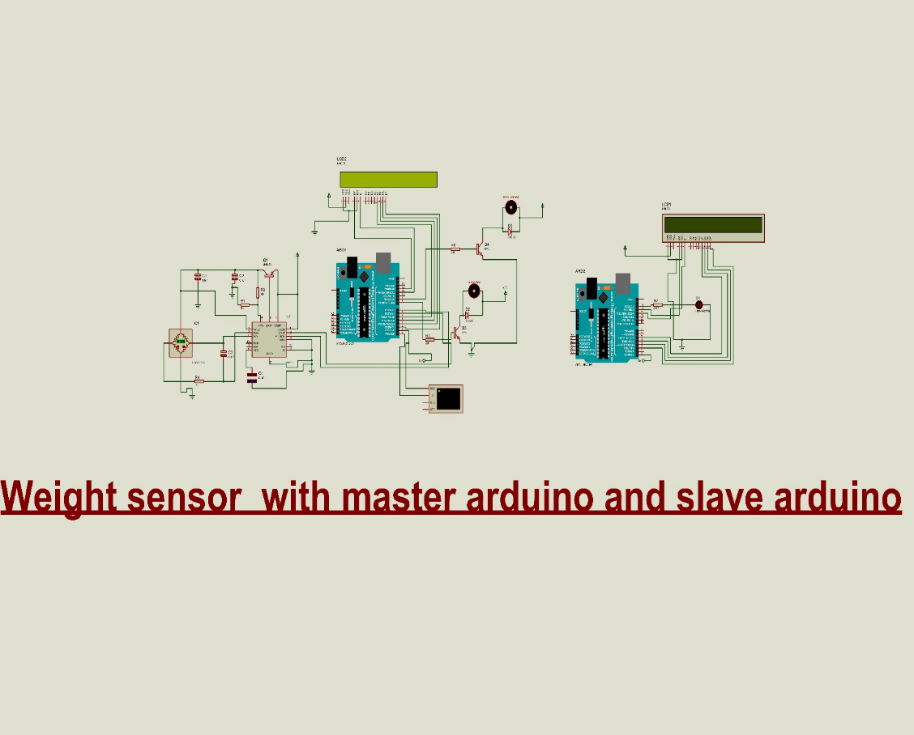

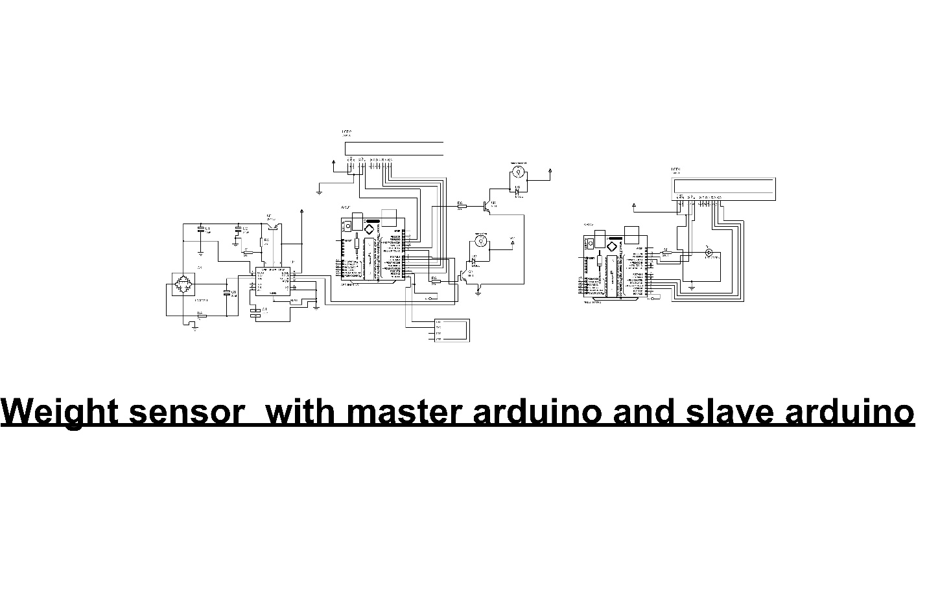

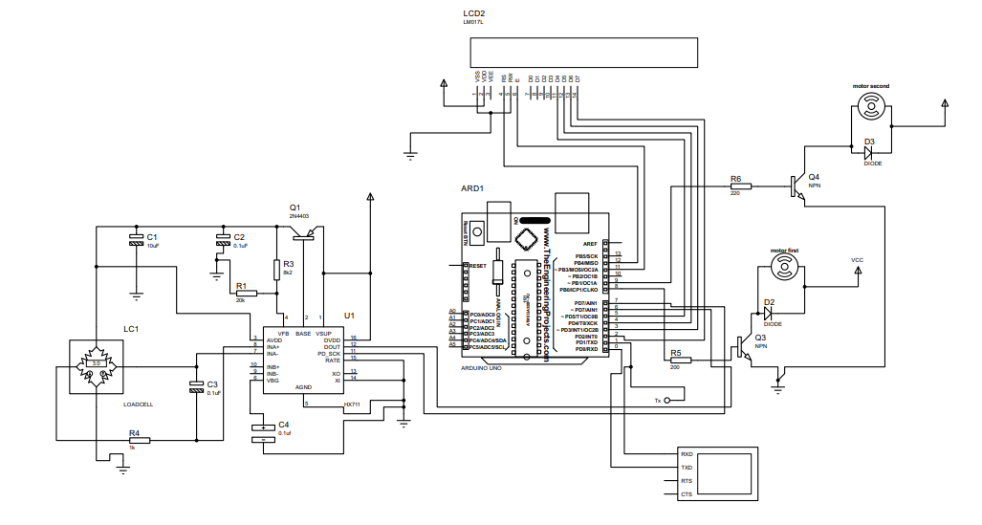

Figure: Master Arduino

# 

Figure: Slave Arduino

# Source code for the above circuit diagram for transmitter

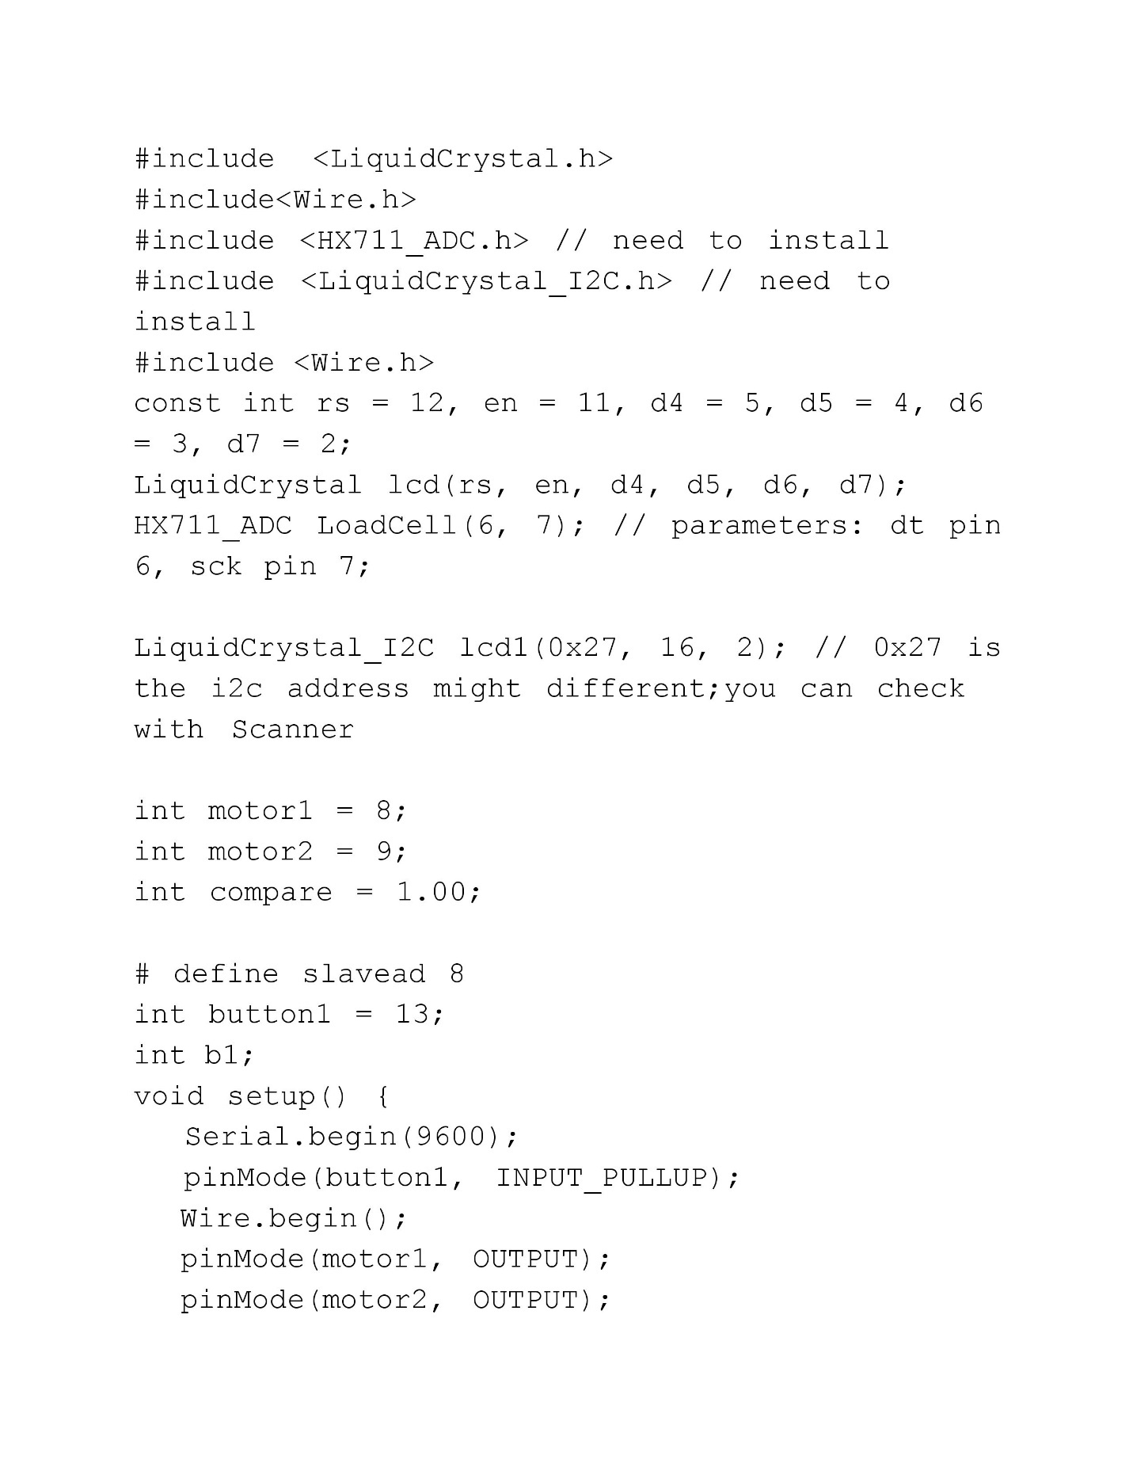

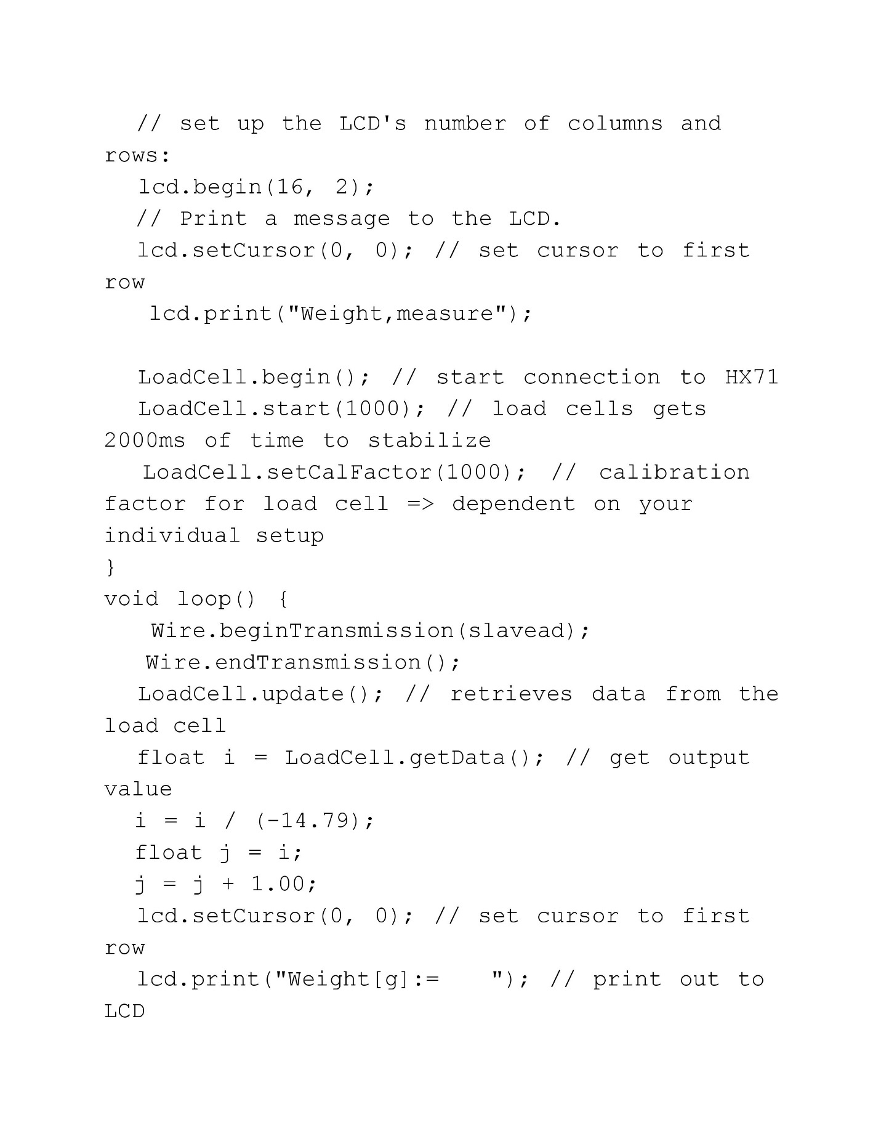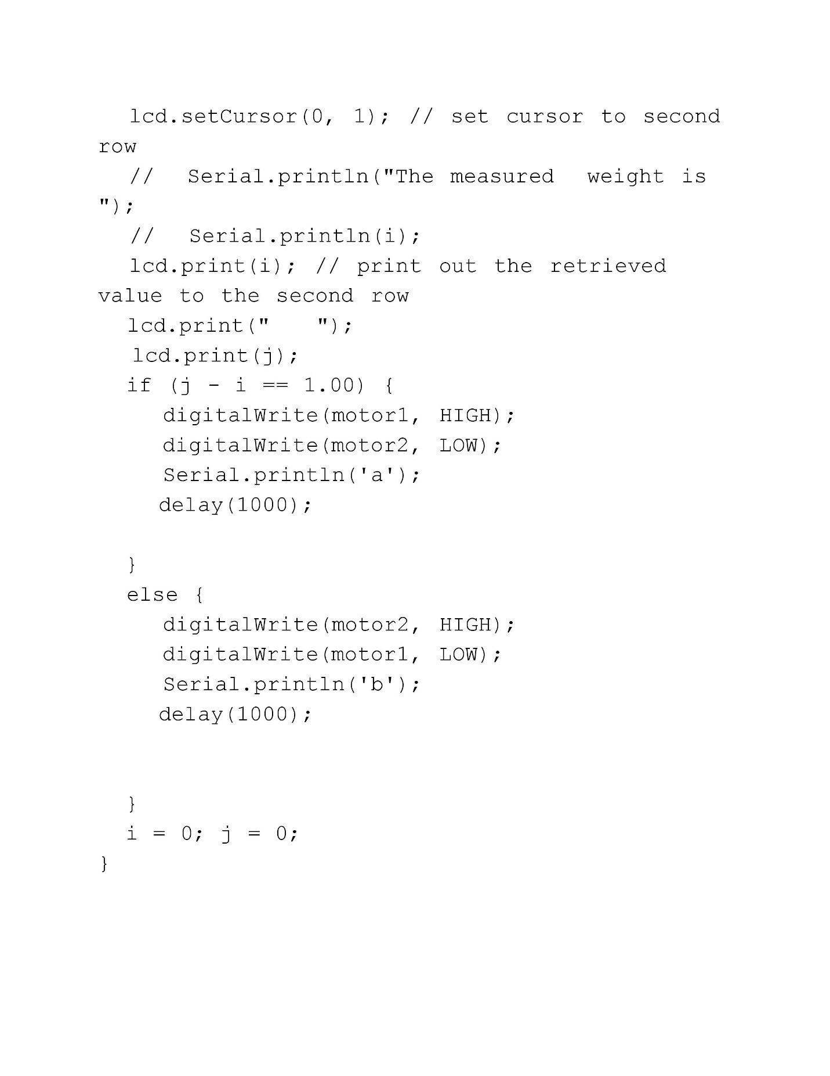

# Source code for the above circuit diagram for Receiver

# 

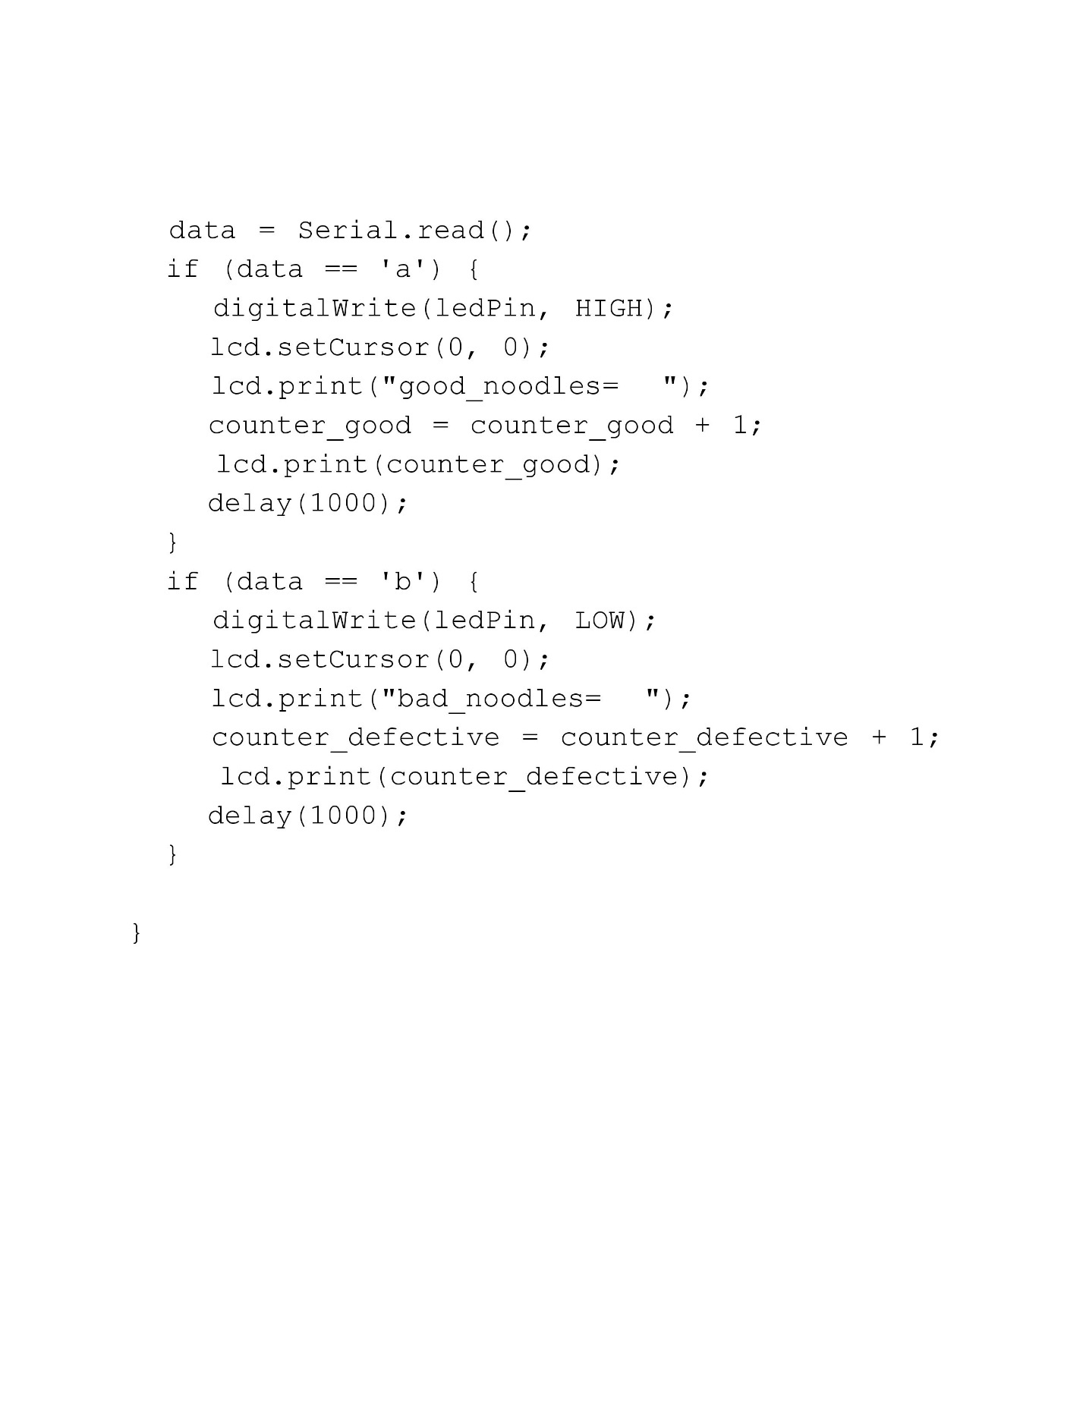

**5. EPILOGUE**

**5.1 RESULT**

The followings were the observed result from our findings:

* The environment friendly practices ensuring safety regulations and a safe working environment for its employees.
* Most of the process such as cutting, and wrapping are done automatically whereas like transporting packed products are done manually.
* There were some defects such as some of the wrapped products were overweight or underweight in the existing system. These defects can be solved by implementation of our proposed system which are explained in this report.

**5.2 DISCUSSION**

The automated machines in each section were properly managed in functioning and used proper guidelines. There were some waste in the production of noodles and packaging wrappers which were found in the existing system.

These problems found in the existing system can be solved to a certain extent with our proposed system. Our proposed system focuses on accuracy of weight held by each packed products in packing unit which can reduce the time taken by packaging and the work area involved increasing the production.

For the implementation of our proposed system still needs more research and applications and depends on the interest of the relative personnel’s.

This proposed system can help the factory’s consistent production and provide the necessary platform for future expansions.

**5.3 CONCLUSIONS**

This case study has helped us to be familiar with real world applications of the knowledge on the working of a production industries that we learned in our engineering course. We learned to improve the ability in critical analysis of creating better system of the existing system. The proposed system for the system has some several advantages as well as drawbacks. The implementation of the design is all upto the authorities. But if the concerned authority could implement our idea, it will certainly help in the production, safety assurance as well as the reduction of work areas. Thus, this study helped us to put our practical knowledge in real working practical system and realized to be more competitive helping in building our career as engineers.

**5.4 FUTURE ENHANCEMENT**

The necessary requirements and explanation for our proposed system with a detail automated system that we have recommended are already explained in this report. If our proposed system gets implemented, it can further improve or strengthen the factory production and making system more automated.

**LIST OF FIGURES**

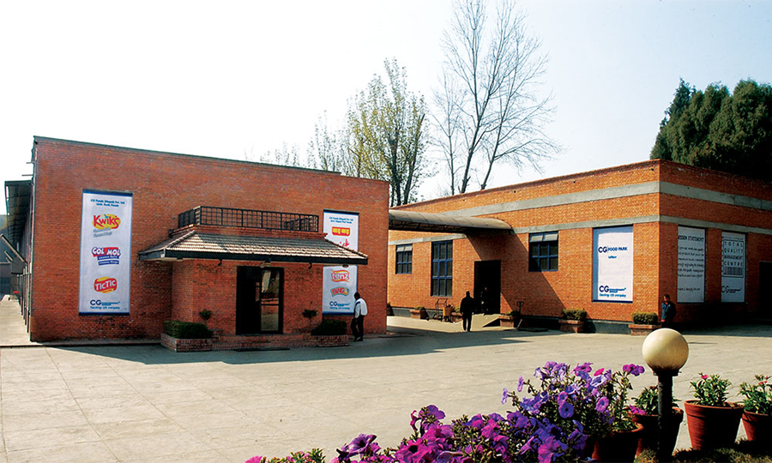

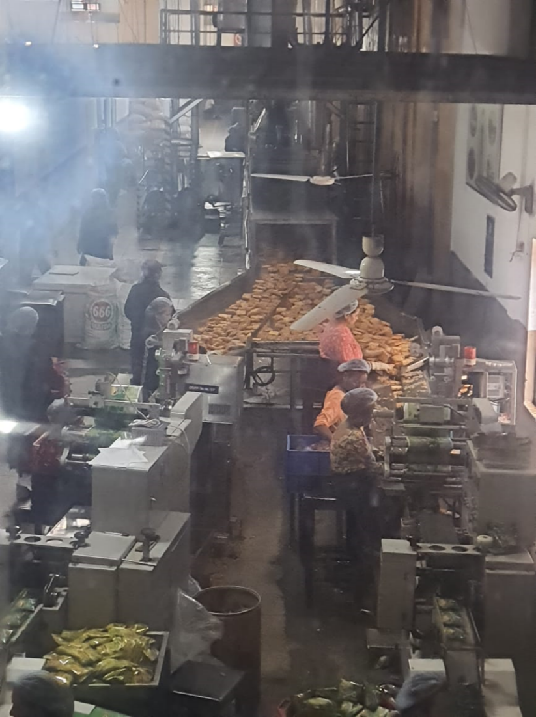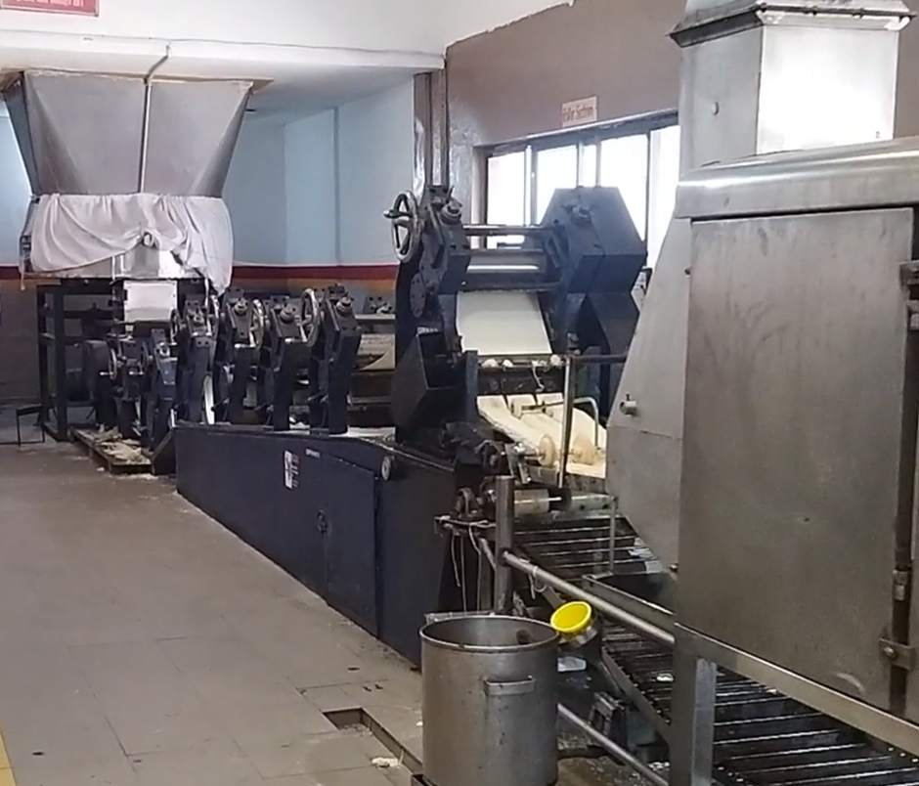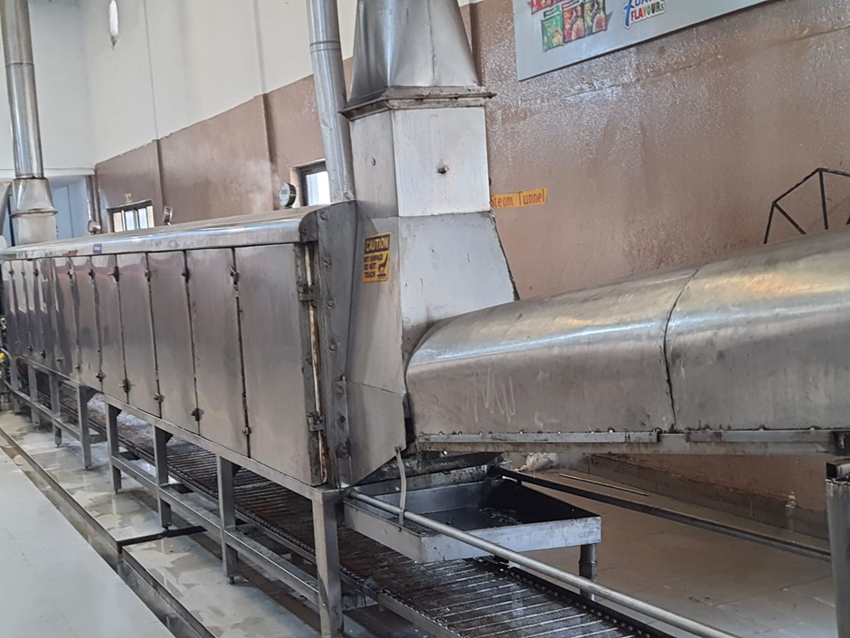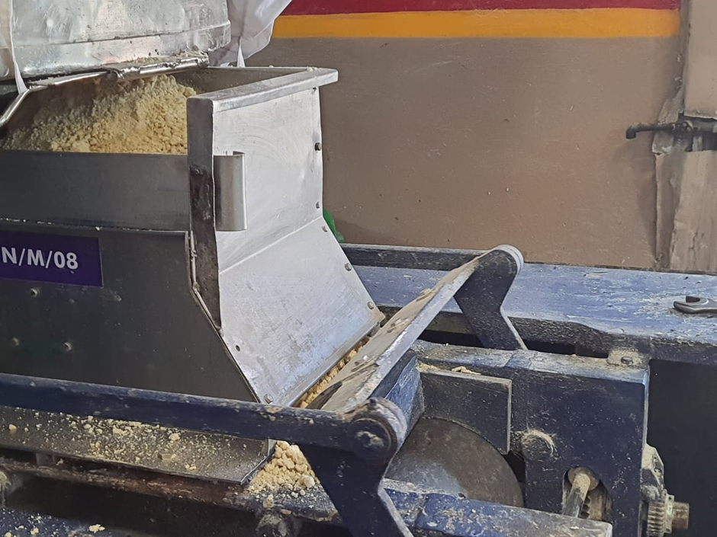

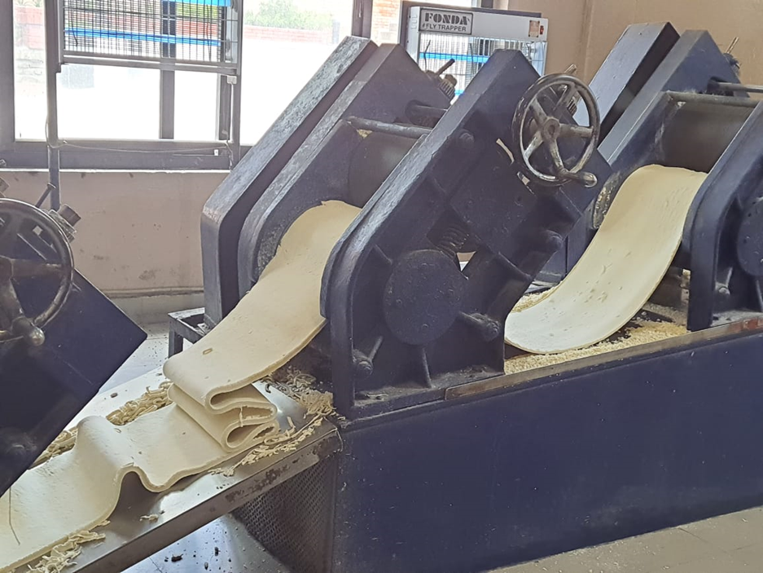

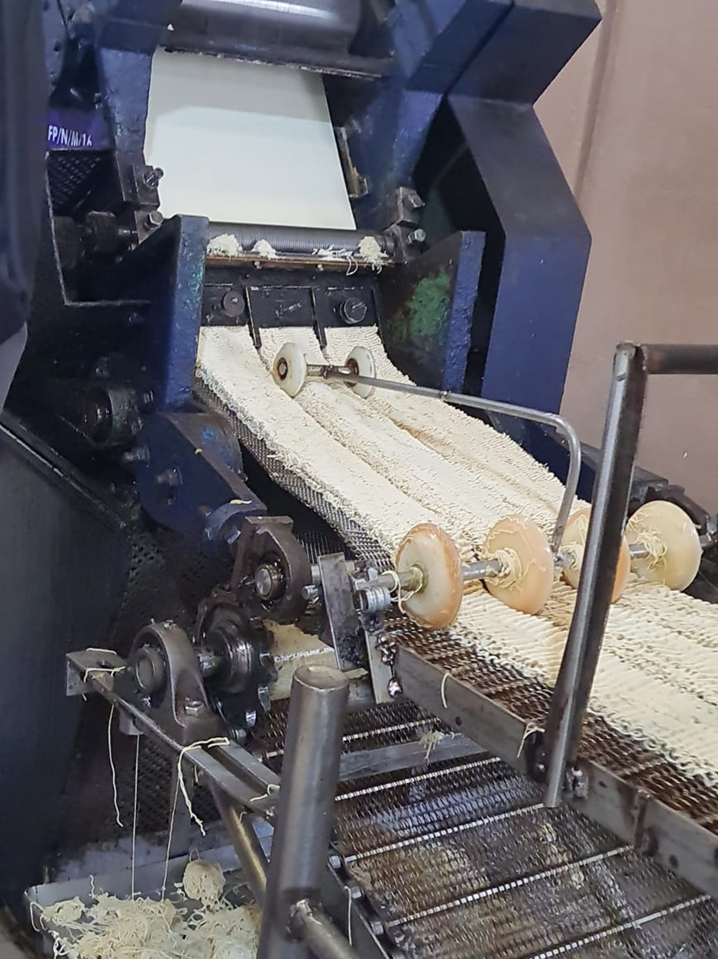

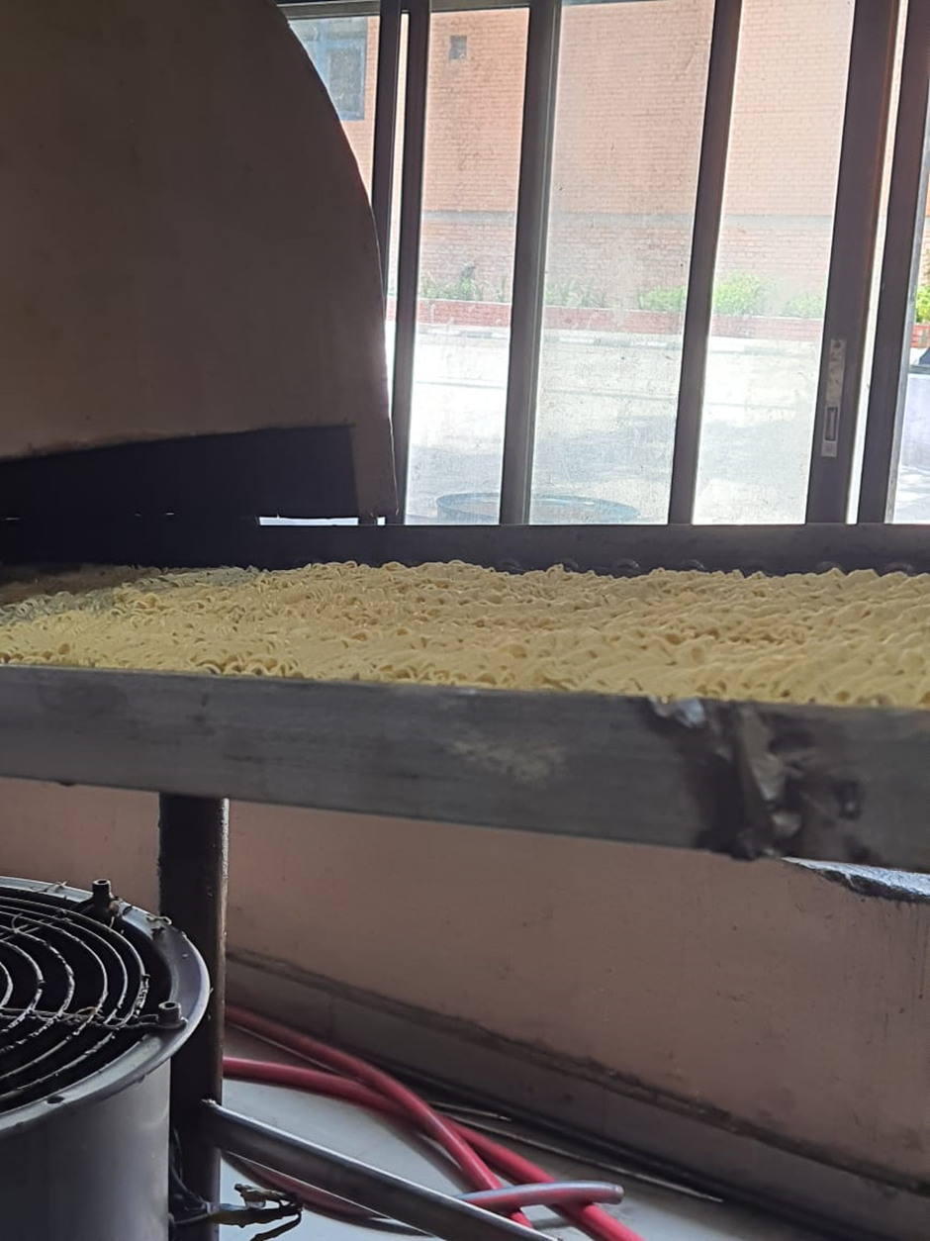

**REFERENCES**

* <https://waiwai.com.np>
* <https://www.tutorialspoint.com/arduino/arduino_reading_analog_voltage.htm>
* <https://sirboatengonline.com/top-8-arduino-projects-in-proteus-with-source-code/>
* <https://nevonprojects.com/arduino-projects/>